Sand Texture Sedimentology —
60 Years of Research

Abstract
Only sand-sized sediments reflect their origin because they form by water flow in the transitional hydrodynamic regime — between the viscous flow (Stokes' law) and turbulent flow (Newton's law). That type of flow modifies strongest the sediment’s granularity (dispersity). Within the transitional range, the laminar layers, getting more energy, gradually separate from the sedimenting particle developing progressively growing turbulence. Particle size is not the genetically effective texture characteristic of sediments and sedimentary rocks. It is the settling rate — (length [distance] in time) that is directly related to the particle transportation and its location in space. Therefore, settling rate, not particle size is to be used as the independent distribution variable — dispersity unit (Rumpf, 1974). To measure the settling rate of sand populations correctly, the particle concentration must not exceed a particle size dependent limit, which is the most demanding measuring requirement. I developed a Sand Sedimentation Analyzer™ fulfilling this requirement. This high technology instrument provides unknown accuracy requiring special care, such as clean and representative sampling. In addition, I developed a Universal Sedimentation Equation that includes Stokes’ law (laminar flow), Newton’s law (turbulent flow) and transitional range between them. The equation is valid not only for spheres but also for non-spherical particles whose shape is defined by Corey’s Shape Factor SF. Furthermore, I developed a Sand Sedimentation Separator™ enabling to take up to 25 samples from a flow of sedimenting particles. On narrow sieve (monosized) fractions, it operates as a Sedimentation Density Separator, capable of isolating heavy minerals and porous microfossils, e.g. Foraminifera, which are not separable by heavy liquids. A few (maximum of five) Gaussian components of perfectly measured settling rate distributions provide the best definition, classification and interpretation of the sand-sized sediment instead of using the current moment characteristics based on higher distribution derivatives.

Introduction
Since World War II, mechanical (clastic) sedimentology continued to follow the pre-war ideas of W. C. Krumbein, especially when studying texture by size distribution. Texture had been measured by two mutually incompatible methods: sieving and settling tubes. The mathematical characteristics of the results soon became very meticulous, and the measuring methods have included many inaccuracies strongly damaging the fine characteristics. Sieving defines the grain size differently from any natural process and is very discontinuous. Settling tubes provide continuous data, use a natural process, but suffered from streaming and particle interactions (Folk, 1962) due to the high concentration of sedimenting suspensions. Economy aspects have shattered any attempt to reduce the concentration: “inexpensive” rather than good quality settling tubes (Emery, 1938, Felix, 1969 and many others) were the ideal – a great lie. Another untruth was the distribution parameters: they are not needed! What do the higher moments and their percentile estimates (asymmetry/ skewness and peakedness/kurtosis) based on higher derivatives say about origin of sediment? They were correlated with a few known terms of origin. The empiricism (correlation) is not a causal relationship. Both deceptions wasted the credibility of all approaches showing that the time should be better used by tatting (Ehrlich, 1983).
To really follow the ideas of Krumbein, I have used in my studies proven procedures and physically-based interpretations only. I have devoted 60 years of systematic work to return the credibility to the sand property —lost after WW II — and bring the old field of Sand Texture Sedimentology to a modern standard of technology. My approach can produce never-before-obtainable results, such as:
- Using Gaussian distribution components as natural tracers of both the material and the streams having transported it (the unique idea of Curray, 1960);
- Reconstructing sedimentation basins;
- Exploring for fluid fossil fuels and heavy minerals.

Independent distribution variable – dispersity unit (Rumpf, 1974)
Particle size is not the genetically effective texture characteristic of sediments and sedimentary rocks, because a size-dependent particle movement (such as sieving) does not form the sedimentary deposit. Instead, the settling rate —length (distance) in time — displays the particle movement (transportation) and its location in space. The substitution of size by particle settling rate is a Kapteyn transformation of the independent distribution variable (Brezina, 1963). Whereas the particle size depends on particle terms, such as particle shape and density, the settling rate depends on environmental terms, such as water temperature, salinity and acceleration due to gravity.
I recommend using standard settling rate, as defined for standard terms (for typical environment). My universal sedimentation equation (Brezina, 1979) can convert it into local terms, particle size etc. The standard settling rate is to be used as the independent distribution variable – dispersity unit of Rumpf (1974). Similarly as Krumbein (1934) used logarithm for size — I did it for settling rate and called it beta (Brezina, 1963); later, I embraced the more consistently defined logarithm PSI by Middleton (1967).
Only sand-sized sediments are controlled by the transitional hydrodynamic regime — between the viscous flow (Stokes' law) and turbulent flow (Newton's law), which modifies strongest the sediment granularity (dispersity): its finest dispersity gradation reflects the sediment's origin (genesis). Within the transitional range, the laminar layers, getting more energy, gradually separate from the sedimenting particle and progressively develop growing degree of turbulence.
Particles finer than sand sediment in water too slowly: they form the sedimentation medium. Their distribution is not controlled by sedimentation, but by other non-sedimentation particle interactions such as coagulation. Coarser particles have also not moved by sedimentation but by gravity shifting.
A normal PSI-settling rate distribution of medium sand corresponds to negatively skewed PHI-particle size distribution (Fig. below). The top left drawing shows the three PSI distributions with the same standard deviation (sd = 1.0 PSI) in a probability PSI diagram plot as three parallel lines, with three different means (-1.0 PSI, -2 PSI and -3 PSI). The three remaining drawings show the three PSI distributions converted into PHI distributions separately, each for 12 values of the variable hydrodynamic Shape Factor (SF’ = 0.1, 0.2, 0.3, 0.4, 0.5, 0.6, 0.7, 0.8, 0.9. 1.0, 1.1 and 1.2). Note that the hydrodynamically defined shape factor may exceed the geometrically defined maximum of 1.0, because an isometric particle (such as cube) with the geometrically defined SF = 1.0 sediments slower than the smooth sphere with the hydrodynamically defined SF’ = 1.2 . All PHI-particle size plots display as curves bent with a four-time stronger slope of the coarser part. As I showed earlier (Brezina 1963), the 1 to 4 ratio is the exponent ratio of the log-particle size in the Stokes (laminar flow) to Newton laws (turbulent/impact flow). This negative skewness has been reported by many authors for water-deposited sands.
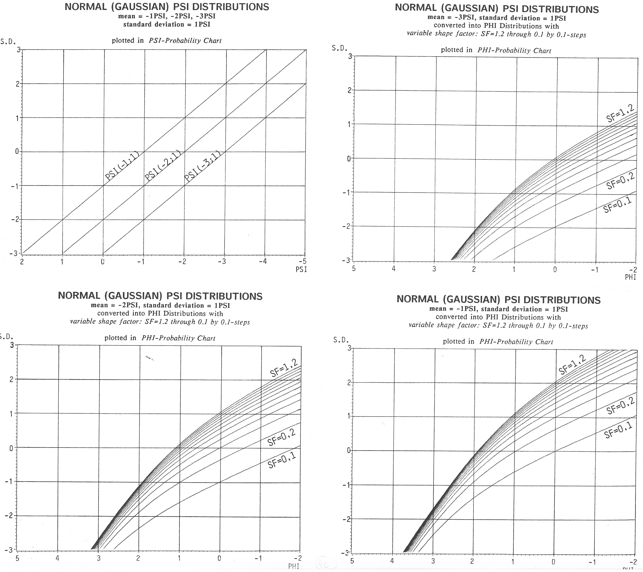
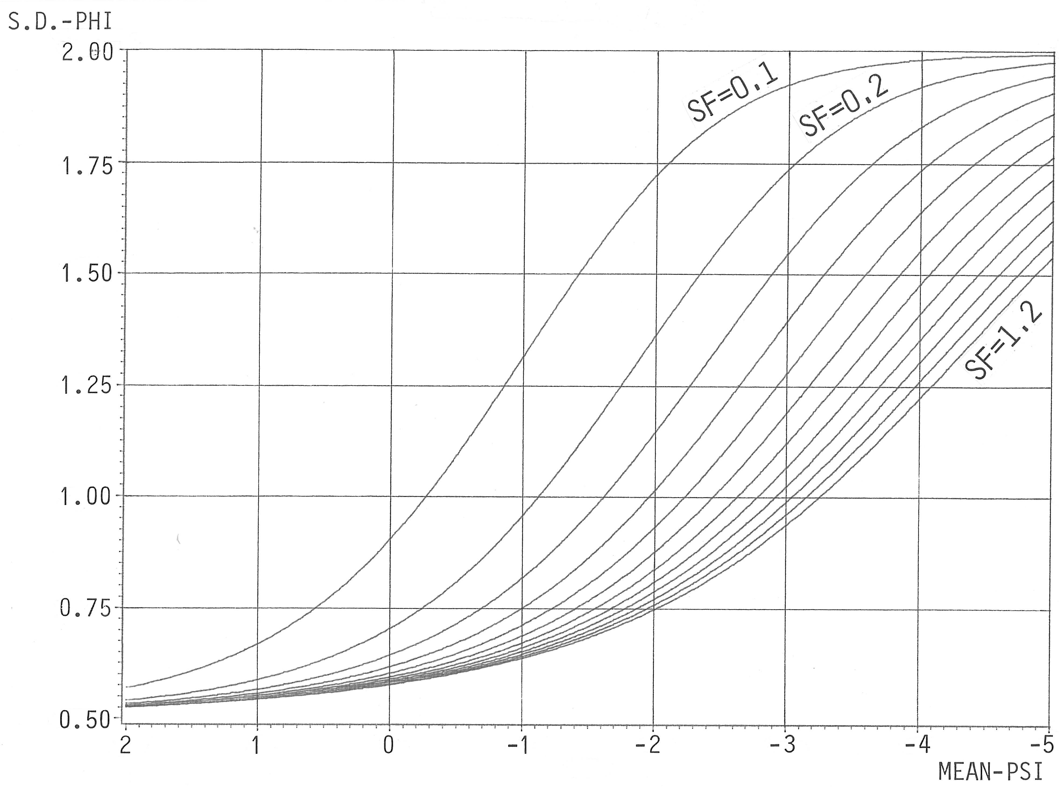 | 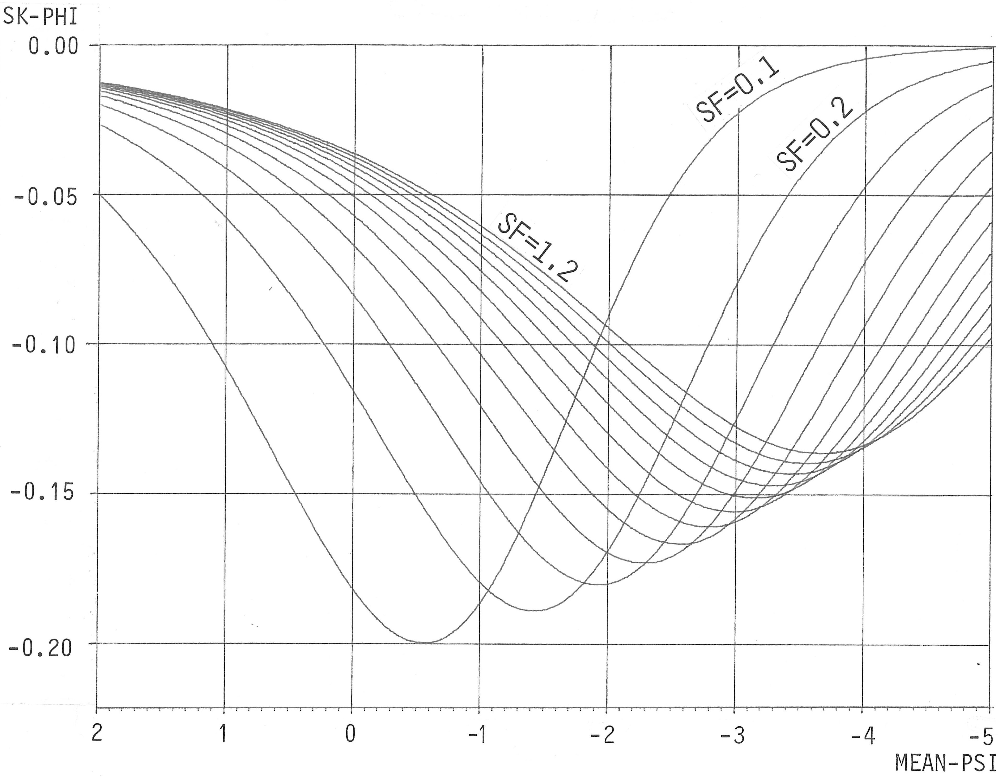

Maximum particle concentration in stratified sand sedimentation
Gravity accelerates the sand-sized particles in water enough that they separate from each other rapidly. This makes possible the use of a stratified sedimentation for them, i. e. from top into clear water, and avoids using Odén's (1915) homogenization of sedimenting suspension that is needed for fine particles that do not separate from each other by sedimentation.
The three most important advantages of stratified sedimentation are:
- knowledge of sedimentation distance of each particle,
- one derivative of the recorded data is saved.
- the rapid reduction of particle concentration in the progress of sedimentation (Figure 1),
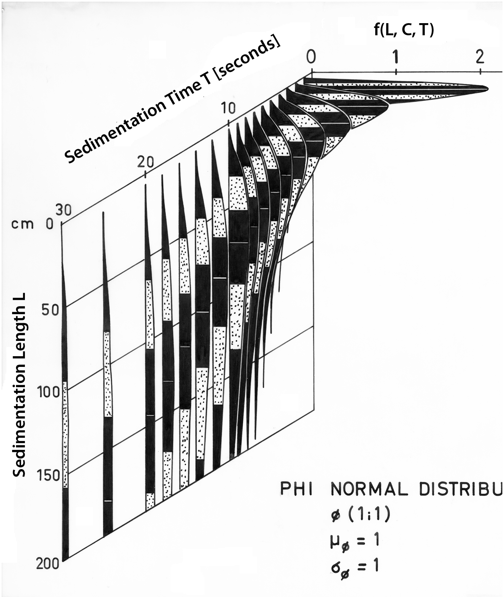
Figure 1: The fast reduction of particle concentration in the progress of sedimentation
In a stratified sedimentation of sand-sized particles, the particle concentration decreases rapidly. A suspension homogenization on top reduces the maximum concentration there.
I focused my experiments onto two types of particle concentration effects: (a) suspension density streaming, and (b) interaction of sedimenting particles. Both these effects have shown that the particle centers are to be 3.4 mm apart from each other at minimum, independent of particle size (Brezina, 1972).
This defines the maximum sample amount to be about 18,000 particles for 20 cm sedimentation column diameter (quartz particle density, medium particle shape SF to be about 0.65, distilled water at about 20°C and standard gravity acceleration).
In grams the maximum sample mass is:
W = 25 d_{c}³,
where d_{c} is the critical particle diameter in millimeters. In the Figure below, the upper straight line displays the above relationship, the lower one shows a similar relationship for statistical representativity. The terminations of both lines converge to constant sample masses.
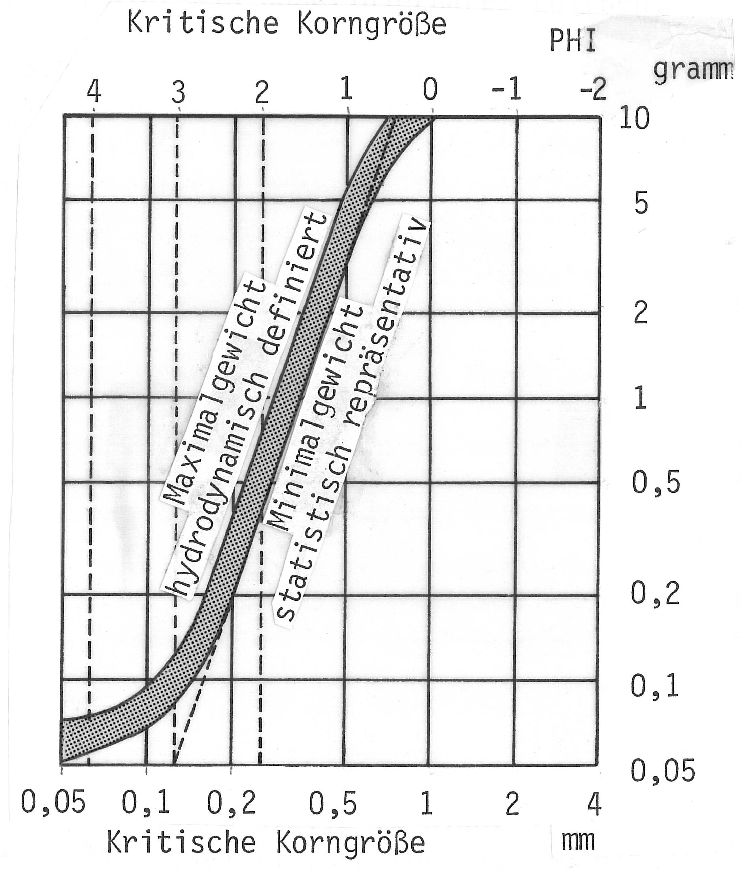
Figure 2: Maximum sample mass for 20cm settling tube diameter
If the sample mass follows the above diagram, then the particle settling velocities are not measurably influenced by collective sedimentation (Brezina, 1971b, 1972a): they sediment as their individual particles in clean fluid would do.
Small sample sizes demand very high sensitivity, high signal to noise (S/N) ratio, and fast response speed from the Analyzer's Underwater Balance. I countered these requirements by incorporating sophisticated technology in my instrument's design. However, the user and operator must work together with the instrument to take advantage of its accuracy and speed. Of special importance is the quality and size of the sample. Quality refers to removing not analyzable materials, such as fines, salt, organics, etc., from the sample. Time and careful attention are required to prepare the samples. Use of a rotational sample splitter (divider) is an excellent way to create samples of the correct size.
On-top suspension homogenization
I developed a special sample introduction device: a Venetian blind with an on-top suspension homogenization. It releases samples quantitatively from the top of the sedimentation column by eccentric rotation of concave lamellae (Figure 3), which vibrate in the open position during the first 7 seconds of sedimentation, thus homogenize and reduce the maximum concentration suspension in the uppermost 5 cm of the column.
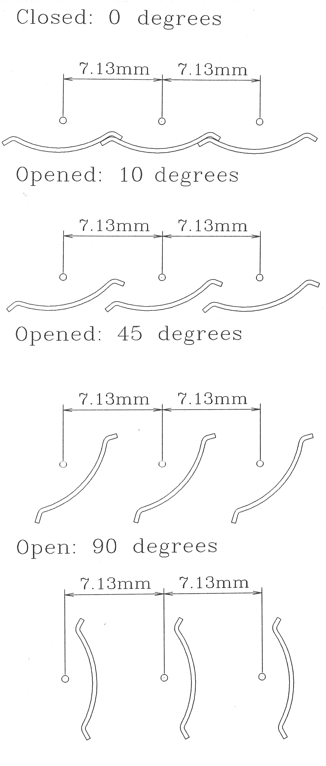
Figure 3_ Eccentric rotation of concave lamellae of the Venetian blind.
Sedimentation column dimensions
The Sedimentation length improves the ratio of the undisturbed to disturbed column lengths: the rapid sedimentation of sand-sized particles in water makes it possible to finish even for the finest sand particles within about 15 minutes; then the optimum sedimentation length is 180 cm.
The Sedimentation column diameter — because the rapid sand sediment accumulation requires a fast and measurable pan weighing depression, the diameter of the balance pan must not exceed 26 cm; because the balance pan must collect all particles which diverge shortly above the pan, the pan radius must exceed that of the sedimentation column by 3 cm. This is why the sedimentation column diameter must be 20 cm.
Sensitivity and speed of weighing
Extremely high weight resolution — the balance output signal is resolved to 0.01 % and adjusted to any sample size (0.05 gram to 5 gram);
Extremely fast underwater weighing — the minimum weighing depression of the balance pan makes it fast and robust.
The reduction of the signal to noise ratio is provided both by strong insulation of the sedimentation column from environmental vibration (the whole sedimentation column is suspended on air shock absorbers) and by mathematical filtering of the balance output signal.

Universal sedimentation equation (J. Brezina, 1979b)
I selected the most precise data on drag coefficient, Reynolds’ number and Shape Factor of sedimenting sand-sized particles, especially those by Schulz, Wilde, and Albertson (1954), and Colby and Christensen (1957). Following their recommendations, I decided to quantify the particle shape by the Corey’s Shape Factor as the hydrodynamically most efficient dimensionless particle shape descriptor (Corey, 1949 and independently McNown and Malaika, 1950):
SF = $\sqrt[2]{\frac{a^{2}}{b.c}}$ ,
where a, b, c are the minimum, medium, and maximum mutually perpendicular particle dimensions.
I used a mathematical relationship for the drag coefficient C_{D} as a function of the Reynolds’ number Re and hydrodynamic Corey’s Shape Factor SF’ (see below) and determined the optimum parameters of the selected trinomial equation by controlled regression. In particular, I adjusted the parameters so, that the equation’s exponent converged to that of the Stokes’ law for log₁₀Re<0.1 and to that of the Newton’s law for log₁₀Re>3. The resulting function permits the explicit calculation of any involved variable, such as grain size, grain settling velocity, grain density, and hydrodynamic grain shape.
Brezina (1979) extended the trinomial equation by Kaskas (1964, 1970) by adding the SF’ shape as a third variable to each term:
C_{D} = A.Re⁻¹ + B.Re^{-0.5} + C [Re >10⁴]
He slightly modified the equation parameters in order to fit also the experimental data by Komar and Reimers (1978) which show a much stronger influence of particle shape on the drag coefficient at low Reynolds’ numbers than assumed earlier:
 | for SF’ =
 | 1.2 | 1.0 | 0.3
A = P₂ SF’^{P1} | 23.963 | 24.66 | 29.80
B = P₄ SF’^{P3} | 4.068 | 4.07 | 4.15
C = P₆ SF^{P5} | 0.37967 | 0.49 | 2.64
Table 1: Three coefficients of the trinomial equation
The parameters P₁ through P₆ :
P₁ =-0.1572509737 | P₃ = -0.0161675868 | P₅ = -1.398809673
P₂ = 24.66 | P₄ = 4.07 | P₆ = 0.49
Table 2: Six parameters of he trinomial equation
The 2-D plot of the upper equation as the Nikuradze diagram is shown in the Figure 4:
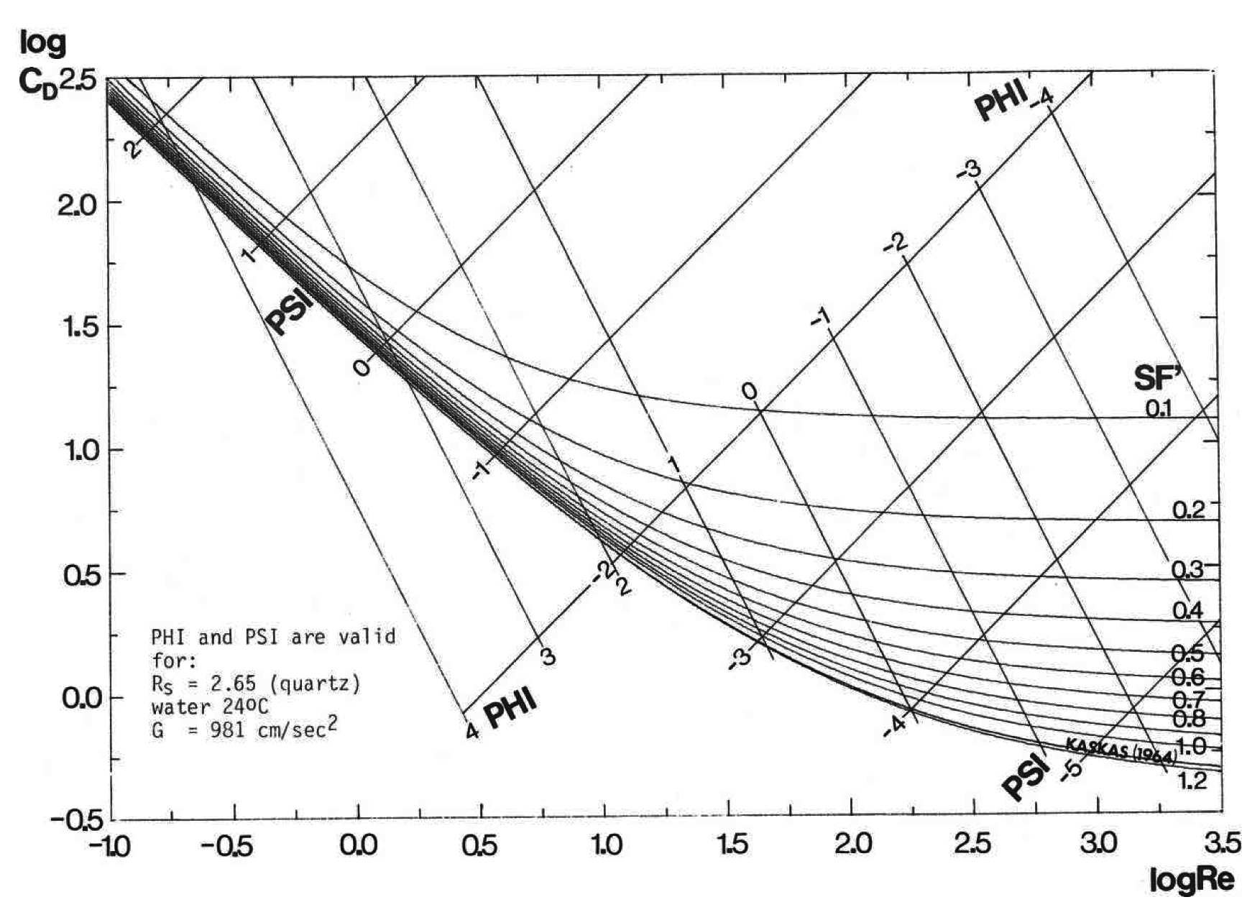
Figure 4: The 2-D plot of the trinomial equation (drag coefficient as a function of Reynolds‘ number and hydraulic Shape Factor SF‘
The diagonal coordinates for the PHI grain size and PSI settling rate are shown for quartz particle density 2.65 g/cm³, distilled water at 24°C temperature and gravity acceleration 981 cm/sec².
The 2-D plot of surface contour lines is shown in the Figure 5.
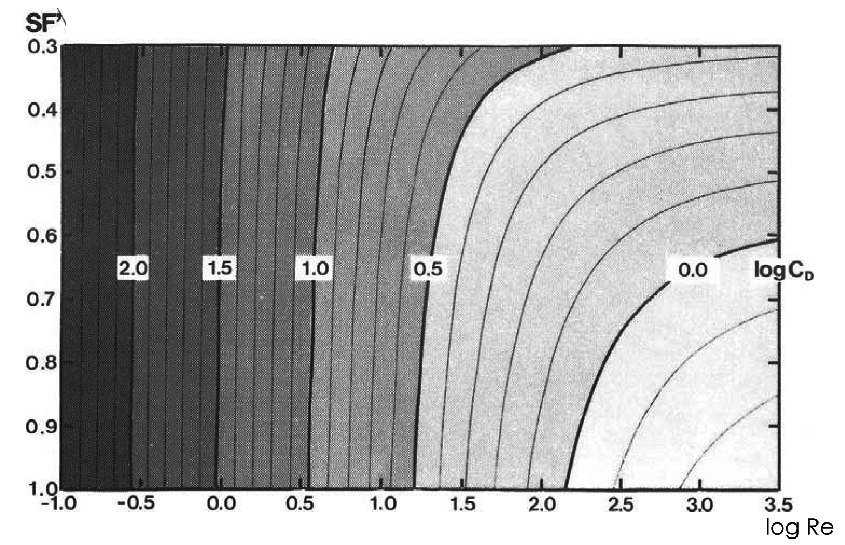
Figure 5: The 2-D plot (the surface contour lines remind an aerial view at the Fig. 6) of the trinomial equation (drag coefficient as a function of Reynolds‘ number and hydraulic Shape Factor SF‘
By geometric definition, the SF values cannot exceed 1.0. The geometric definition does not distinguish SF of a sphere from that of a cube whose one side is parallel to any of the three mutually perpendicular particle dimensions. However, the cube and similar isometric non-spherical bodies fall slower and have greater drag coefficient than the spheres. This hydrodynamic behavior defines a hydrodynamic Shape Factor SF’, which slightly exceeds the value of 1.0 for smooth isometric bodies such as the sphere: their extrapolated hydrodynamic SF’ approaches the value 1.18 (in the Figure 4, I used the rounded value 1.2 for scaling reasons; mathematically, the SF’ values may be even greater, such as 1.5 in the Figure 6).
The 3-D plot of the equation is shown in the Figure 6:
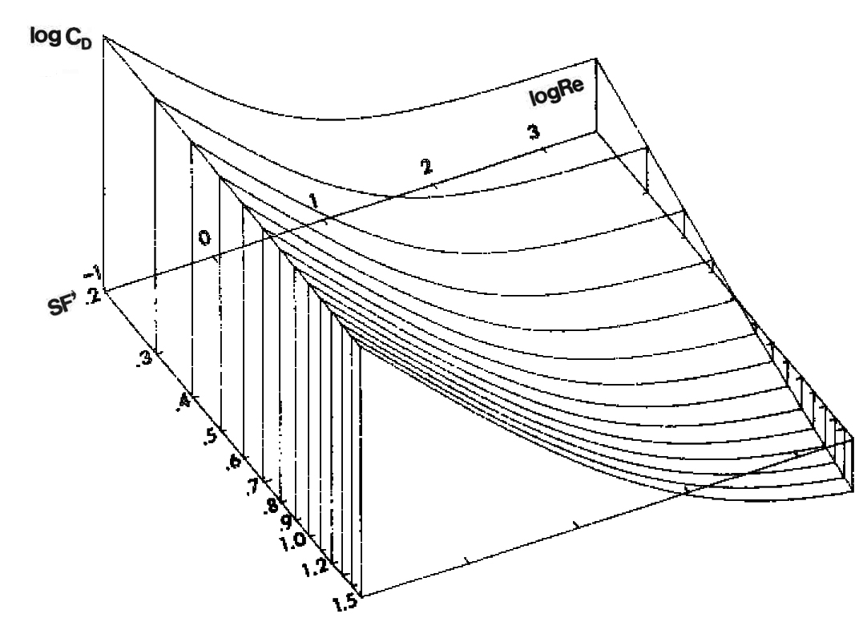
Figure 6: The 3-D plot of the trinomial equation (drag coefficient as a function of Reynolds‘ number and hydraulic Shape Factor SF‘
My SedVarNC™ and SedVarDC™ programs compute the variables numerically using the Newton-Raphson convergence. Brudowsky (2006) has developed algebraic solutions of my equations.
If a spherical shape is used instead of the actual shape of the natural particles, the size of such a speed-equivalent sphere diameter is much smaller than the speed-equivalent particle diameter. Figure 7 shows the size reduction of sphere diameter of non-spherical particles for various SF’ values in dependence on the PHI-particle size.
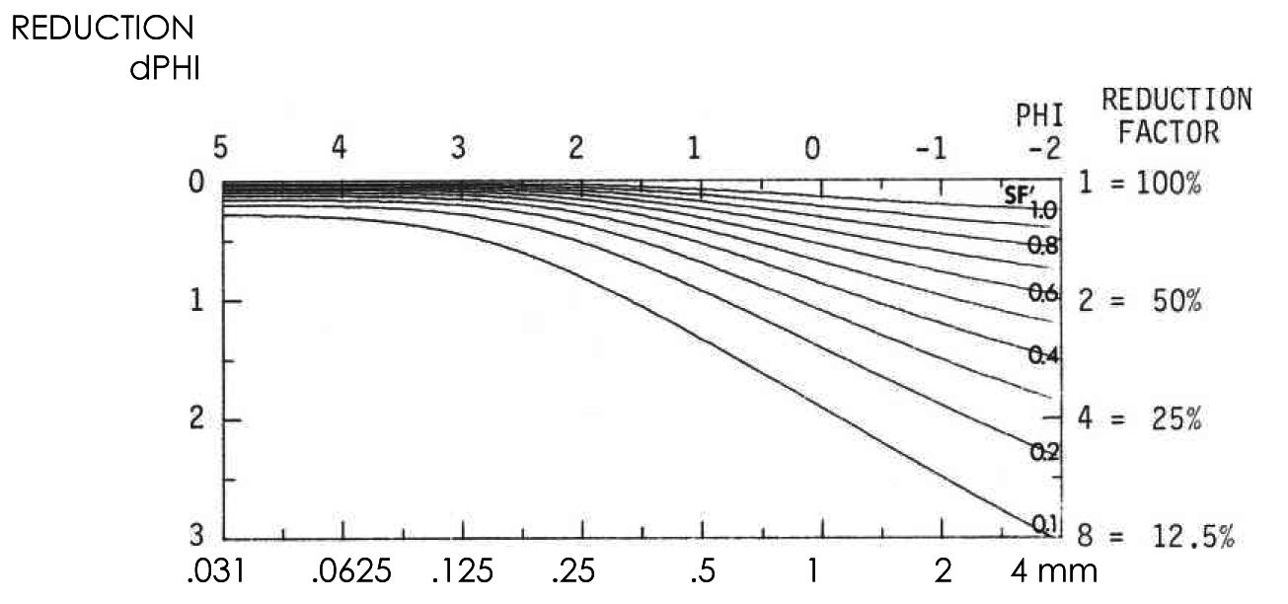
Figure 7: The size reduction of sphere diameter of non-spherical particles for various SF’ values in dependence on the PHI-particle size
The PSI settling rate (Y axis) as function of the PHI particle size (X-axis) for four densities R_{s} (left)and four shape factors SF’ (right) is shown in Figures 8 and 9. The diagonal coordinates of Reynolds number, logRe, and drag coefficient, logC_{D}, are valid for standard terms. Note that the influence of particle shape on the settling rate increases with particle size (diverging curves), whereas the particle density influence on the settling rate does not change with particle size (parallel curves).

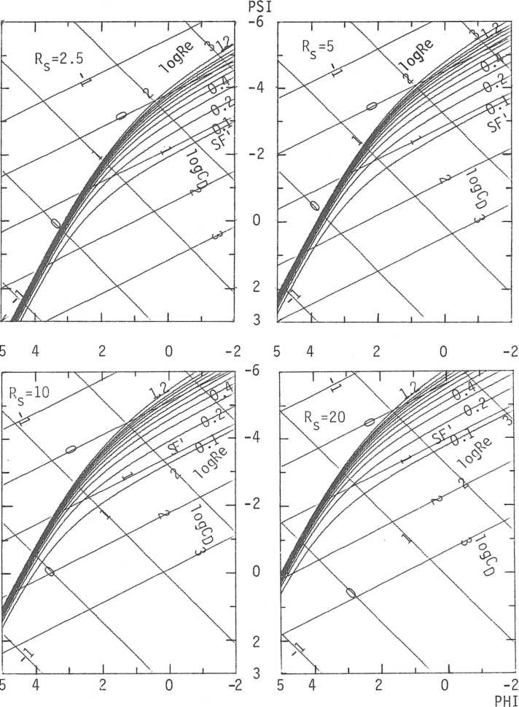 | 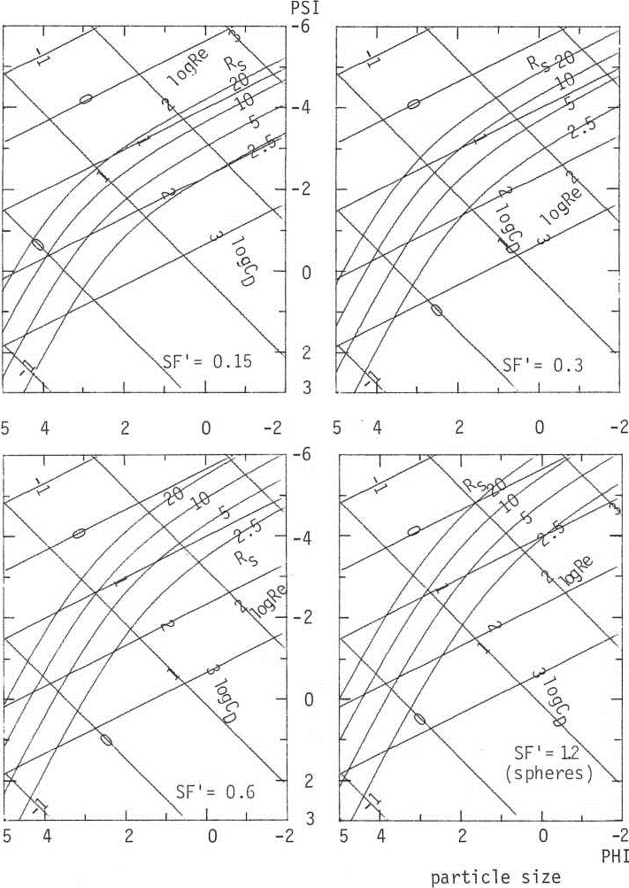
Figure 8: Settling rate PSI (Y-axis) as function of the particle size PHI (Y-axis) for four shape factors SF’ | Figure 9: Settling rate PSI (Y-axis) as function of the particle size PHI (Y-axis) for four densities R_{s}

Sand Sedimentation Analyzer™
To measure sand settling rate distributions as composed from settling rates of single particles, I have developed the Sand Sedimentation Analyzer™ and have modified it twenty-times since 1972 through 2001 for various research institutes in Europe and Africa. An example of one of the latest versions is shown in Figure 10 (the Control Electronics, Carrier Frequency Measuring Amplifier and PC are outside of Figure 10) as I delivered it to the Geologic Institute of the University of Vienna, Austria in 1998. This high technology instrument provides not yet known accuracy requiring special care and patience, such as clean and representative sampling. Only strictly analyzable material must be used (no dirt, fines, solubles etc.). The appropriately small (but representative) sample size must be obtained by long time sample splitting using a precision rotational sample splitter.
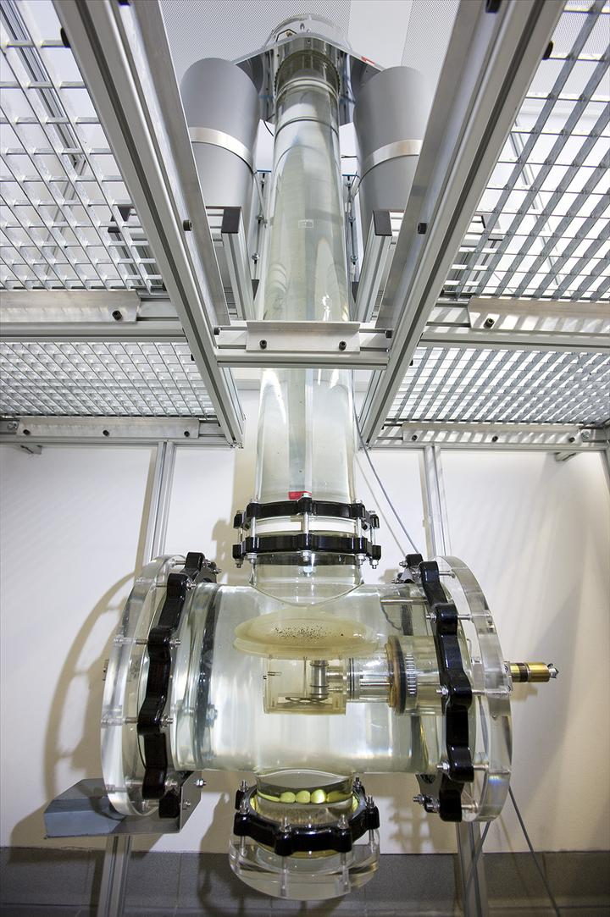
Figure 10: Sand Sedimentation Analyzer, Geol. Inst., Uni. Wien, Austria; Photo by Louis Lammerhuber,
All its parameters fulfil the above listed requirements at or above minimum standards. As described earlier in the chapter “Maximum Particle Concentration in Stratified Sedimentation”, a Venetian blind (Figure 11) introduces samples into the top of the sedimentation in a 20 cm inner diameter column of a tube made of 0.8 cm thick borosilicate glass. The sedimentation length is 180 cm. Samples are evenly spread onto the closed Venetian blind lamellae 0.7 cm below water surface which is tightly closed during the sedimentation.
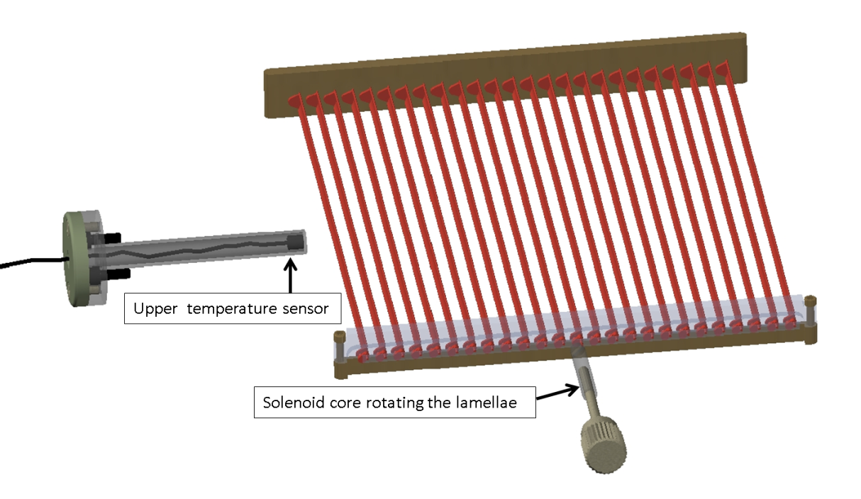
Figure 11: Sample introduction device – Venetian blind
An Underwater Electronic Balance (Figure 12) is positioned at the bottom of the settling column through the side opening of the column. A vertical rod (red) is the balance axle carrying the balance pan (dashed red) and two soft-magnetic plates (full red) extend over both active ends of the differential transformer (blue). The balance axle is fixed to the free ends of the two double-leaf springs (light blue). The cylindrical double-coil differential transformer (blue) can be shifted along its vertical axis within the balance body (dashed gray) by an eccenter of a horizontal rod (not shown) for zeroing the balance mechanically. The measuring distance between the soft magnetic plates (red) and active ends of the differential transformers (blue) is shorter than 0.1 mm.
Figure 12: Underwater electronic balance
The differential transformer is connected with a 5 kHz Carrier Frequency Measuring Amplifier external to the Underwater Electronic Balance. An external electronic control unit outputs signals to
- the rotary solenoid that opens the Sample Introduction Device (Venetian Blind),
- a slow-speed motor that tilts the Underwater Balance for sediment removal from its pan, and
- upper and lower electronic temperature sensors.
The Operational software GRM™ runs on a PC under the Microsoft Windows operation system. Special software SedVar™ processes the recorded PSI-lab distributions.

Sand Sedimentation Separator™
In addition to the previously delivered Analyzer™, Professor Jörn Thiede, Geomar, Geologic Institute, University Kiel, Germany, contracted me in 1986 to deliver a new Sand Sedimentation Separator™. I developed it within two years. The instrument allows up to 25 samples to be taken from a continuous flow of sedimenting particles. It uses the same sample introduction device and sedimentation column as the Analyzer™, except that the column suspension is rigid. Instead of the Underwater Balance of the Analyzer, a Separation Unit is plugged into the column opening near the bottom (Figure 13). The Separation Unit consists of the Sediment Flow Rectifier and the Alternately Collecting and Flushing Chambers below the Rectifier. Outside of the Column are a Sample Collector, Flushing Water System and Electronics controlled by special PC software.
The Sediment Flow Rectifier arranges the sedimenting particles into one vertical plane without changing their vertical settling rate. It consists of two convergent conveyer belts composed of thin polypropylene foils each driven by a stepping motor. Their 45° tilt requires that their speed must be by the square root of two (1.414) times faster than the instantaneous particle settling rate, which is known at any instant since the sample introduction and decreasing. In this manner, the settling particles retain their vertical settling rate on the tilted belts. I determined by using a fast motion picture camera (64 FPS) that all particles move with the belts and do not slide. The fast and short steps of the motors and the minimum lower edge radius support the particle separation from the belts – no particle remains on the returning belts.
The Alternately Collecting and Flushing Chambers are two open long cylindrical boreholes near the surface of a larger cylinder, whose rotation shifts the chambers alternately into collecting and flushing positions.
In the collecting position, the chamber’s long opening allows the collection of the settling particles and those from the lower edge of the conveyer belts. The chamber in the flushing position is tightly closed, so that a horizontal flushing water stream moves all accumulated particles through a suspension stream decelerator outside of the settling tube into one of the 25 collecting funnels with a porous bottom. No particle is lost while rectifying their settling path, in the Separation Unit, acceleration and deceleration stages up to the collecting funnels.
The Flushing Water System is a water circuit completely separated from the water of the sedimentation column. It maintains a constant stream of water at 16 Liter/minute. Upon computer signal, electromagnetic valves deflect an exact quantum of flushing water to rapidly stream through the flushing chamber into one of the collecting funnels. Part of the flushing water system is a cylindrical container, covered on top by a disk with 25 openings for the funnels, dripping off the suspension water back into the container. After a funnel is filled by the separated sample, an electrical motor turns the disk by 1/25 of its circumference (the exact position is checked by a photo-cell).
The PC program enables the operator to enter the separation instants in a PSI-settling rate (with an accuracy of 0.01 PSI), and print out the analysis protocol: sample identification, separation fractions, water temperatures in the upper and lower portions of the sedimentation column, analysis date and time, and operator’s name.
On narrow sieve fractions (monosized), the Sand Sedimentation Separator™ operates as a density separator, with uses such as isolation of heavy minerals and porous microfossils, e.g. Foraminifera, which are not separable by heavy liquids. Compared with a heavy liquid separation of heavy minerals, the Separator™ is precise and practically continuous (the separation of the narrowest fraction takes about 3 seconds only). Heavy liquids separate between two densities only — not continuously. Heavy liquids are electric insulators: the particle friction charges them electrically and forms clusters that interfere with the density separation. And, most heavy liquids are toxic.
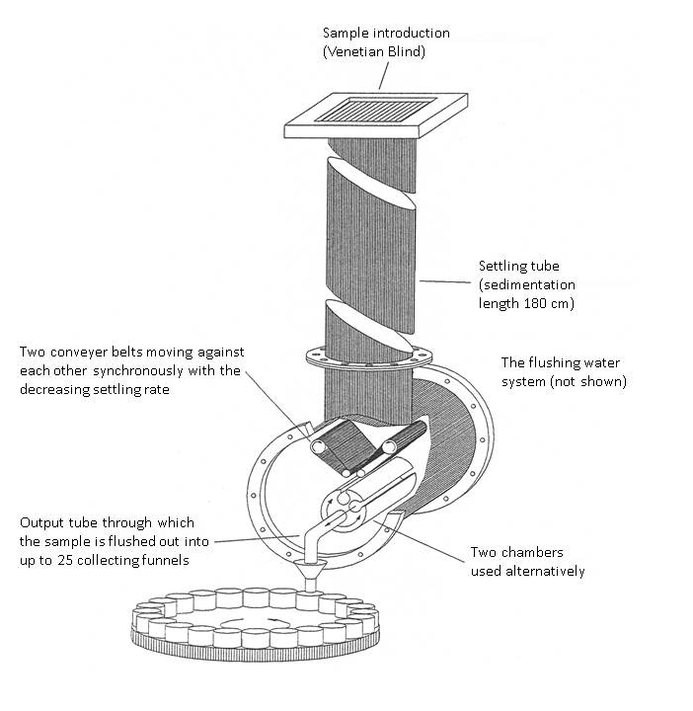
Figure 13: Sand Sedimentation Separator™

Distribution decomposition — distribution identification
My program SHAPE™ defines a distribution by mixture of (3n-1) Gaussian components with the following parameters (n is the number of Gaussian components):
n means, n standard deviations and (n-1) percentages.
Though the number of components is unlimited, I limited it to 5, in order to distinguish components from random effects, such as sampling and laboratory errors and measuring noise.
Decomposition Example
Accuracy of the Sand Sedimentation Analyzer™ cannot be substantiated by comparison to other instruments, because it is the most accurate instrument of its kind. The following decomposition example provides the best evidence of its accuracy.
The material analyzed by the Sand Sedimentation Analyzer™ and mathematically decomposed is a sand fraction of nearly monosized grains, created by use of precision sieves with circular holes. The time to carefully sieve out 0.6916 grams of the monosized fraction took 8 hours. The table below shows the data:
Material | beach black sand | sample 13 | at a 90° intersection of beaches
Locality | near Casusay | Venezuela Bay | about 110 km NNW of Maracaibo
Sampling Date | 1972-5-15 | low tide | tide amplitude: about 75 cm
Analysis date, time; temperature | 1981-2-1, 16:55h  T_{mean} = 24.76°C
Preparation | precision wet vibration sieving |  | circular holes ± 0,002 mm
MonoSized | 1.770 ±0.0639 PHI | = 0.297±0.013 mm
Average of 8 sample split analyses | Total Mass | 0.6916 gram | SF’ = 0.63 (calculated Corey‘s Shape Factor)
 | Mean Sample  Split Mass | 0.08645 gram | G_{lab} = 980.962 gal (cm/sec²)
Figure 14 shows the graphical and numerical output of the decomposition of the above sample:
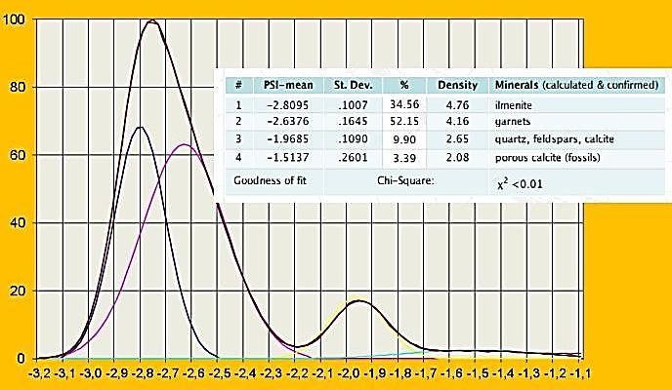
Figure 14: Distribution decomposition (example)
Curray (1960) had demonstrated graphically a pioneering idea: the decomposition of sieved PHI distribution into a mixture of Gaussian components and used the components as natural tracers of sand moved by water streams. Van Andel (1974) used a special analog computer for subtractive solution of Curray’s manual decomposition (DuPont Curve Resolver 810). In contrast to artificial tracers, which are marking material admixtures (e.g. radioactive and color tracers [such as fluorescein]), disperse and disappear in space and time, the natural tracers are intrinsic properties of the sand sediment, they cannot disperse and disappear: only adjust to the changing environment.
I applied the Curray's idea to PSI distributions measured by my instrument and decomposed them into a few (up to 5) Gaussian components using the program ROKE with the unique algorithm by Clark (1977), such as in the above example. The first two moments and percentages of each of the Gaussian components identify and specify the measured (mixed) distribution. Only Gaussian distribution and its first two moments have physical meaning, whereas the higher (3rd and 4th) moments and similar parameters do not.
My program SHAPE
As mentioned above, the SHAPE calculates the input PSI distribution defined by components, and also, after entering the PHI sieving distribution of the same sample, it finds – through the equality of the inverse distribution functions – the PSI-PHI couples, from which it calculates the pertinent SF’ values by using my Universal Sedimentation Equation. This is the only known method how to determine SF’ Shape Factor values to each PHI-distribution value (from the PSI distribution output of my Sand Sedimentation Analyzer™ and the PHI-sieve distribution of the same sample). Though it is a unique method, it strongly suffers from the input analytical errors. Unfortunately, I could not yet test the method on too many samples. In any case, it provides one advantage: it enables analyzing by the Sand Sedimentation Analyzer™ as it would be by sieving (inclusively the sieving errors). The SF’ distribution may be specific not only for the given facies and/or source material, but also for the special features of the sieving, such as sieving time etc..

Acknowledgments
Profits from the sale of this instrumentation made possible my research and development. I am thankful to my many colleagues who work primarily at universities and in petroleum industry (Agip, San Donato Milanese, Italy, and SNEAP Elf Aquitain, Boussens, France). At the same time, I have been teaching physical and environmental geology, astronomy and physical science more than 7000 students at University of Maryland Europe, later Planetology for geologists at Charles University, Prague, Czech Republic, and I am grateful to them for support in various ways as well.
I am very thankful to both Isobel Clark (Geostokos, United Kingdom) and Malcolm W. Clark (Computer Centre, Imperial College of Science and Technology, University of London, United Kingdom), who helped me in implementation of the program ROKE into my program SHAPE in all stages of its evolution.

References
Brezina, J., | 1963 | Kapteyn’s transformation of grain size distribution: | Journal of Sedimentary Petrology, v. 33, no. 4, December, p. 931 – 937.
Brezina, J., | 1971b | Investigations on an instrument for sedimentation analysis in the particle range above 60 µm (in German): | Report about research studies of the author at the Institute for Mechanical Engineering, University of Karlsruhe (1968 - 1971); unpublished typewritten report for the German Society for Scientific Research, DFG, 48 pages
Brezina, J., | 1972a | Stratified sedimentation above the Stokes' range and its use for particle size analysis: | M. J. Groves & J. L. Wyatt-Sargent (editors), 2nd Particle Size Analysis Conference, University of Bradford (England), September 1970, paper 22, The Society of Analytical Chemistry, London, p. 255 - 266
Brezina,. J., | 1972b | Leaf-spring precision balance (in German): | German Patent Office (Deutsches Patentamt), No. 2251838, registered October 1972, effective 1974.
Brezina, J., | 1979 | Particle size and settling rate distributions of sand-sized materials: | PARTEC Partikel Technologie Nürnberg, 2nd European Symposium on Particle Characterisation, Paper Session 1, E Sedimentation.
Brudowsky, J. M., | 2006 | Mathematical Addendum: | Unpublished comment to Brezina (1979).
Clark, I., | 1977 | ROKE, a computer program for non-linear least squares decomposition of mixtures of distributions: | Computer and Geosciences, Pergamon Press, v. 3, p. 245 – 256.
Colby, B. C., and Christensen, R. P., | 1957 | Some fundamentals of particle size analysis: | St. Antony Falls Hydraulic Laboratory, Mineapolis, Minnesota, USA, Report Nr. 12 Dec., 55 pages.
Corey, A. T., | 1949 | Influence of shape on the fall velocity of sand grains: | Thesis, Colorado Agricultural and Mechanical College, Fort Collins, Colorado, USA, December, 102 pages.
Curray, J. R., | 1960 | Tracing sediment masses by grain size modes: | Report of the Twenty-First Session Norden, International Geological Congress, Copenhagen, 1960, p. 119 – 130.
du Pont Instruments, | 1973? | 310 DuPont Curve Resolver 810: | DuPont Instruments, Analytical Chemistry, 20A
Ehrlich, R., | 1983 | Size analysis wears no clothes, or, have moments come and gone?: | Editorial, Journal of Sedimentary Petrology, v. 53, no. 1 March, p. 1.
Emery, K. O., | 1938 | Rapid method of mechanical analysis of sands: | Journal of Sedimentary Petrology, v. 8, no. 3, p. 105-111.
Felix, D. W., | 1969 | An inexpensive settling tube for analysis of sands: | Journal of Sedimentary Petrology, v. 39, no. 2, p. 777-780.
Folk, R. L., | 1962 | Of skewnesses and sands: | Journal of Sedimentary Petrology, v. 32, no. 3, p. 105 - 111.
Kaskas, A. A., | 1964 | Berechnungen der stationären und instationären Bewegung von Kugeln in ruhenden und strömenden Medien Wien (in German): | Diplomarbeit am Lehrstuhl für Thermodynamik und Verfahrenstechnik der Technischen Universität Berlin.
Kaskas, A. A., | 1970 | Schwarmgeschwindigkeit in Mehrkornsuspensionen am Beispiel der Sedimentation (in German): | Doktor-Ingenieur-Dissertation, Institut für Verfahrenstechnik, Fakultät für Maschinenwesen der Technischen Universität Berlin, 164 pages.
Komar, P. D., and Reimers, C. E., | 1978 | Grain shape effects on settling rates: | Journal of Geology, v. 86, no. 2 March, p. 193 – 209.
Krumbein, W. C., | 1934 | Size frequency distribution of sediments: | Journal of Sedimentary Petrology, v. 4, no. 2 August, p. 65 – 77.
McNown, J. S., and Malaika, J., | 1950 | Effects of particle shape on settling velocity at low Reynolds’ numbers: | American Geophysical Union Transactions, v. 31., No. 1 February, p. 74 – 82.
Middleton, G. V., | 1967 | Experiments on density and turbidity currents; III Deposition of sediment: | Canadian Journal of Earth Sciences, v. 4, p. 475 – 505, especially p. 484 – 485.
Odén, S., | 1915 | Eine neue Methode mechanischen Bodenanalyse Wien (in German): | Internationale Mitteilungen für Bodenkunde, Band 5, p. 257 – 311.
Rumpf, H., | 1975 | Mechanische Verfahrenstechnik (in German): | Carl Hanser Verlag, München, Wien, 138 pages, p. 8.
Schulz, E. F., Wilde R. H. and Albertson. M. L., | 1954 | Influence of shape on the fall velocity of sedimentary particles: | Colorado Agricultural and Mechanical College, Fort Collins, Colorado, USA, MRD Sediment Series, No. 5 July (CER 54EF56), 161 pages.
van Andel, Tjeerd "Jerry" H., | 1973 | Texture and dispersal of sediments in the Panama Basin; | Journal of Geology, v. 81/1973, No. 4/July, p. 434 - 457.

Table of Figures
Figure 1: The fast reduction of particle concentration in the progress of sedimentation 4
Figure 2: Maximum sample mass for 20cm settling tube diameter 5
Figure 3: Eccentric rotation of concave lamellae of the Venetian blind. 6
Figure 4: The 2-D plot of the trinomial equation (drag coefficient as a function of Reynolds‘ number and hydraulic Shape Factor SF‘ 8
Figure 5: The 2-D plot (surface contour lines) of the trinomial equation (drag coefficient as a function of Reynolds‘ number and hydraulic Shape Factor SF‘ 8
Figure 6: The 3-D plot of the trinomial equation (drag coefficient as a function of Reynolds‘ number and hydraulic Shape Factor SF‘ 9
Figure 7: The size reduction of sphere diameter of non-spherical particles for various SF’ values in dependence on the PHI-particle size 9
Figure 8: Settling rate PSI (Y-axis) as function of the particle size PHI (Y-axis) for four shape factors SF’ 10
Figure 9: Settling rate PSI (Y-axis) as function of the particle size PHI (Y-axis) for four densities Rs 10
Figure 10: Sand Sedimentation Analyzer, Geol. Inst., Uni. Wien, Austria; Photo by Louis Lammerhuber 11
Figure 11: Sample introduction device – Venetian blind 12
Figure 12: Underwater electronic balance 12
Figure 13: Sand Sedimentation Separator™ 14
Figure 14: Distribution decomposition (example) 15

Table of Equations
1 Maximum sample mass W in grams 3
2 Corey’s Shape Factor, geometric definition 5
3 Drag coefficient as a function of Reynolds‘ number and Corey’s Shape Factor SF‘ 5

Table of Symbols
Throughout, cgs units of the SI system are used, except for special uses, such as
particle size is in millimeters.
a, b, c mutually perpendicular minimum, medium and maximum particle dimensions 5
A, B, C coefficients of the trinomial equation 5
C_{D} drag coefficient https://en.wikipedia.org/wiki/Drag_coefficient 5
d_{c} critical particle diameter in millimeters (90th fine percentile of a distribution) 3
FPS frames per second frame rate https://en.wikipedia.org/wiki/Frame_rate 11
log logarithm to the base of 10 (decadic) https://en.wikipedia.org/wiki/Logarithm 6-8
n number of mixed distribution Gaussian components (#) 12-13
PHI, PSI negative logarithm to the base of 2 (binary), PHI grain size and PSI settling rate 6-8
P₁ to P₆ parameters of the trinomial equation 5
Re Reynolds’ number https://en.wikipedia.org/wiki/Reynolds_number 5
RS density of solids in g/cm³, originally ρ_{S}, density of solids versus ρ_{F}, density of fluids 6, 8
SF Corey’s Shape Factor, geometric 5
SF’ Corey’s Shape Factor, hydrodynamic 6, 7
W maximum sample mass in grams for unhindered stratified sedimentation 3
Χ² chi-square, goodness of fit measure https://en.wikipedia.org/wiki/Chi-squared_test 13

